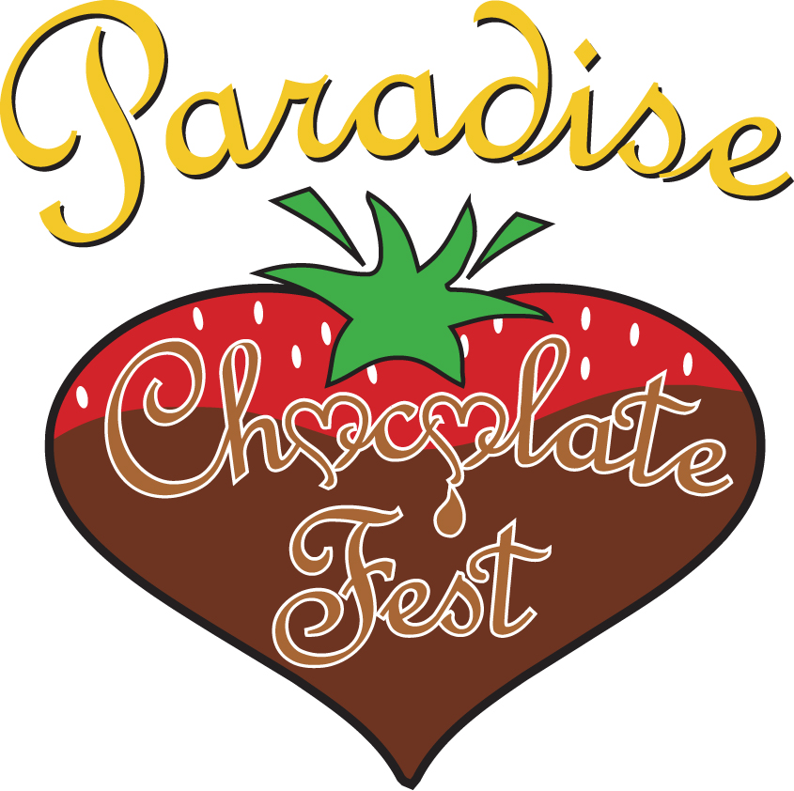The 2017 Paradise Chocolate Fest celebration includes “All About Books!”
connecting Authors, Illustrators & Publishers to the Community.
As a special part of All About Books - Paradise Chocolate Fest is pleased to announce
“Young Author’s Writing Contest!”

Students K-12 on the Paradise / Magalia Ridge are invited to join the fun and festivities of this year’s Paradise Chocolate Fest as we celebrate literacy for students. The Paradise Chocolate Fest Young Author’s Writing Contest seeks to encourage young people to develop enthusiasm for, and expertise in, their writing successes. The contest aims to inspire entrants to express themselves and their thoughts through writing and literary skills to create a fictional story.

Contest Rules:
● Contest open to all students currently enrolled in Paradise/Magalia schools, grades K-12.
● Entries must include the word “Chocolate” in the story.
● Deadline to submit is April 18, 2017. Mailed entries must be postmarked by April 18, 2017.
● All entries must be an original creation.
● Only one entry per person may be submitted.
● Age Categories:
K-1, 2-3, 4-5th grades (no minimum or maximum number of words; illustrations may be included.)
6-7-8, 9-10, 11-12th grades (500-2,000 words; entries must be typed; Font 12 point Times New Roman
or Arial; no illustrations.)
● A completed Entry Form must be paper clipped to each entry.
● Top of first page must include the Title of your story. Please, Do NOT put your name on your story.
(Your Name should be on Entry Form only, attached to your submission by paperclip.)
● All entrants under 18 years old are required to provide parent/guardian approval of their entry (see Entry Form).
● Be creative, be bold and have fun!
● Entries become the property of Youth on the Ridge Community Foundation, Inc. / Paradise Chocolate Fest and
may be included in an anthology of youth stories, benefiting Paradise Chocolate Fest youth groups in future years.

Judging: Each story is judged on its literary merit as a short story including: story structure (plot, characters, and setting) style, grammar and creativity. Judging will be by a panel of local educators and community members.

Awards: Contest results will be announced at Paradise Chocolate Fest, Saturday, May 13, 2017 at 11:00 am
on the Chocolate Fest’s Main Entertainment Stage.
● All entries will receive 2 Tickets to the Paradise Chocolate Fest.
● K-1, 2-3, 4-5th grades -
1st Place winner & First two runners-up – Ice Cream Certificate, Darlene’s Fine Chocolates & Ice Cream.
● 6-7-8, 9-10, 11-12th Grades -
1st Place winners will be awarded $40 Barnes & Noble Gift Certificate.
First two runners-up will each be awarded $20 Barnes & Noble Gift Certificate.

Submission Guidelines:
Mail entries to: PARADISE HIGH SCHOOL c/o Virginia Partain 5911 Maxwell Drive Paradise, CA 95969

In the past 7 years alone, the Paradise Chocolate Fest has distributed over $154,000.00 to organizations which provide educational, enrichment, recreation and leadership opportunities to youth on the Paradise Ridge. This year, twenty organizations will benefit. These vital funds support music & academic programs, provide scholarships to summer camp and dance classes, youth leadership training, sports equipment, food banks, upgraded computers and much, much more.

Youth on the Ridge Community Foundation, Inc. / Paradise Chocolate Fest
Debbie LaPlant Moseley, Executive Director ● 530/342-4896 ● info@chocolatefest.us ● www.chocolatefest.us
IRS Tax Exempt #27-0772654

"For information only. Paradise Unified School District policy does not allow the endorsement of non-school sponsored activities"
Paradise Chocolate Fest
Young Author’s Writing Contest
Official Entry Form
(please see writing contest announcement for complete contest rules and submission guidelines)

Deadline to submit is April 18, 2017. Mailed entries must be postmarked by April 18, 2017.

Remember – Do Not Put Author’s Name on Story.
Include Title at the Top of your Story.
Paperclip this Entry Form to the Title Page of your Story.

(Please print legibly)

Title of Story: _____________________________________________________________________________________

Student/Author’s: ________________________________________________ School: ________________________
First Name Last Name

Home Phone: __________________________ Email Address: _________________________________________________

Classroom Teacher: ___________________________________________ Grade: ___________
(For grades 6-12, write the name of your English Teacher)

I, __________________________________, give permission for Paradise Chocolate Fest to retain ownership of Student’s/Author’s story. Student & parent signatures confirm that this is the original work of the above author.

_______________________________________________ __________________________________________
Student/Author’s Signature Parent or Guardian Signature

Mail Entries To: PARADISE HIGH SCHOOL c/o Virginia Partain 5911 Maxwell Drive Paradise, CA 95969

Youth on the Ridge Community Foundation, Inc. / Paradise Chocolate Fest
Debbie LaPlant Moseley, Executive Director ● 530/342-4896 ● info@chocolatefest.us ● www.chocolatefest.us
IRS Tax Exempt #27-0772654

"For information only. Paradise Unified School District policy does not allow the endorsement of non-school sponsored activities"

