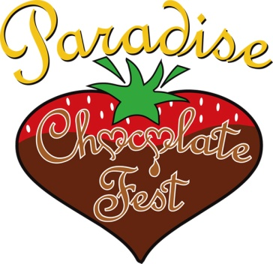CONTACT: Debbie LaPlant Moseley
Executive Director Youth on the Ridge Community Foundation, Inc. / Paradise Chocolate Fest
530/342-4896 debbie@chocolatefest.us www.chocolatefest.us

July 16, 2015 FOR IMMEDIATE RELEASE

Chocolate Fest Celebrates Sweet Success with Youth Organizations on the Ridge!

Youth organizations on the Paradise Ridge are celebrating the sweet success of this year’s 10th Annual Paradise Chocolate Fest. Leaders of the Paradise Chocolate Fest awarded over $21,000 to organizations serving youth in our community at a special ceremony held July 14 at Paradise Community Park.

Held each May, the Paradise Chocolate Fest benefits non-profit organizations which provide educational, enrichment, leadership and recreational opportunities to youth on the Paradise Ridge. This year, twenty-three organizations have benefited from the “sweet rewards” of the Fest.

The Paradise Chocolate Fest was founded in 2006 by Bill and Pam Hartley, owners of Joy Lyn’s Candies with the support of a multitude of community volunteers to benefit the Boys & Girls Club of Paradise Ridge. In 2010, with tremendous community support, the festival was incorporated into its own non-profit organization, and has continued to thrive. Since then, over $135,000 has been contributed back to local youth charities directly from the Paradise Chocolate Fest.

Ranking among the top festivals in the state, the Paradise Chocolate Fest is ‘choc-full’ of all day fun for the entire family. At the Fest, you can wow your taste buds with artisan-produced chocolate delights and rub shoulders with multi-award winning Chocolatiers. Tap your toes to musical entertainment while you savor an ice cream sundae or visit the Chocolate Cuisine Challenge. Dive into the chocolate pie eating contest, or enjoy fine art and crafts booths, delicious food, giant inflatables, costumed characters and so much more.

“I am proud to be a part of an organization that brings people together and gives back to the youth of our community. The Fest is a winning combination that’s as sweet as the chocolate we celebrate”, said Debbie LaPlant Moseley, Executive Director of Paradise Chocolate Fest.

2015 Beneficiaries - Achieve Charter School, Boy Scouts Troops #316 & #770, Cub Scouts Pack 316, Evergreen 6 Academy, Girl Scouts, Gold Nugget Museum, Heart Shine Foundation, Northern California Ballet, Paradise Dancers, Paradise Elementary School Chorus, Paradise Friends of the Library, Paradise Piranhas Swim Team, Paradise HS Cross Country, Paradise HS Girls Basketball, Paradise HS Musical Production, Paradise Lutheran Church Youth, Paradise Rotary Interact, Paradise Youth Soccer, Rainbow Girls, Simple Gesture, Strings In School and Youth for Change.

The Board of Directors of the Chocolate Fest has developed three (3) opportunities for youth organizations to benefit from the Fest. –
• Volunteer Equity Program – Distributable funds are allocated to qualified youth organizations based on the number of hours contributed by their volunteers. Funds are multiplied by the calculated hourly rate for the Fest. The hourly rate attributed to each volunteer is determined by dividing the net distributable funds by the total number of qualified volunteer hours. Over 2,000 hours were contributed to this year’s Chocolate Fest at a rate of $9.00 per hour. “I give credit to a dedicated, hardworking Board of Directors and staff and a focused team of committee members, but I know all would agree that the true thanks goes to that passionate volunteer who know that their hard work at this event translates directly into a donation to their favorite youth organization,” noted Sherry Swim, president of the Board of Directors.

• Grant Reserve – An allocation taken from distributable funds of the Paradise Chocolate Fest to support specific programs or projects of non-profit youth organizations. This year’s Grant Awards support dance and camp scholarships, homeless food services, field trip outings, leadership development and many more vital programs.

• Complimentary Booth Space at the Fest – Youth organizations are invited to set-up a booth at the Fest to raise funds - 100% of the income that they earn, they keep. Members from each non-profit group decorate their booths; sell cookies, candy, club memberships and this year, even chocolate whoopie pies. Coming together in the name of fun, youths and mentors of all ages work alongside one another in their “fun” fundraising quest. Along the way, they are also raising awareness and the sense of community resonates and grows.

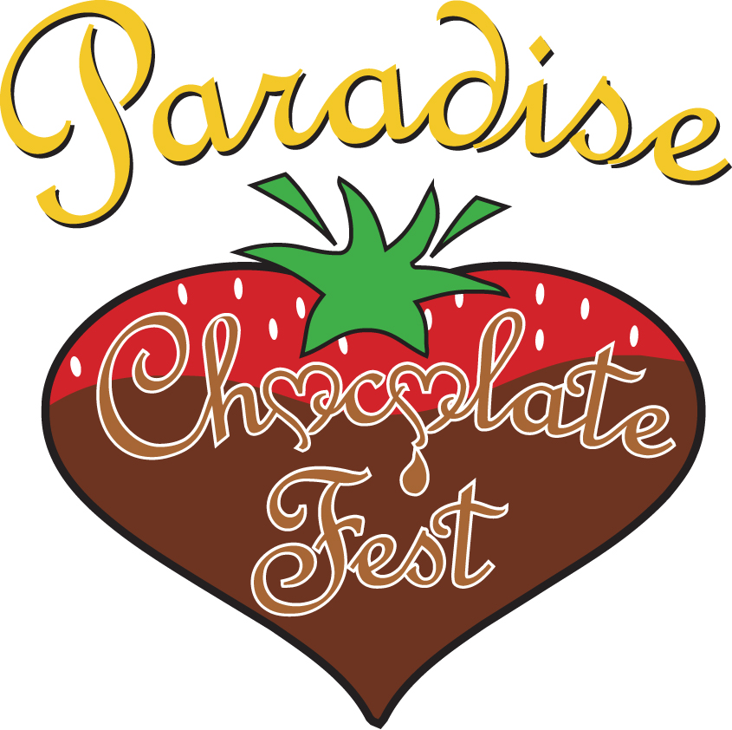 2015 PARADISE CHOCOLATE FEST AWARDS

2015 BENEFICIARIES | TOTAL AWARD | IN SUPPORT OF PROGRAM/PROJECT
ACHIEVE CHARTER SCHOOL | $1,119.50 | Fine & Performing Arts Programs
BOY SCOUT TROOP #316 | $1,851.75 | Camp Scholarships & Equipment
BOY SCOUT TROOP #770 | $2,096.50 | Scholarships & Equipment
CUB SCOUT PACK #316 | $1,899.25 | Scholarships & Equipment
EVERGREEN 6 ACADEMY | $278.75 | Environmental Studies
GIRL SCOUTS | $1,818.25 | Scholarships
GOLD NUGGET MUSEUM | $500.00 | Pioneer & Maidu Indian Programs
HEART SHINE FOUNDATION | $680.25 | Leadership & Community Support
NORTHERN CAL BALLET | $150.00 | Scholarships & Production Costs
PARADISE DANCERS | $570.25 | Production Costs
PARADISE ELEMENTARY CHORUS | $317.00 | Music & Production Costs
PARADISE FRIENDS OF THE LIBRARY | $1,785.75 | Summer Reading Program
PARADISE HS CROSS COUNTRY | $409.00 | Uniforms & Meet Fees
PARADISE HS GIRLS BASKETBALL | $731.25 | Uniforms & Tournament Fees
PARADISE HS MUSICAL PRODUCTION | $346.50 | Production expenses
PARADISE LUTHERAN CHURCH YOUTH PROGRAM | $150.00 | Youth programs
PARADISE PIRANHAS SWIM TEAM | $644.24 | Scholarships & Equipment
PARADISE ROTARY INTERACT | $200.00 | Community Service Projects
PARADISE YOUTH SOCCER | $1,719.75 | Travel & Tournament fees
RAINBOW GIRLS | $531.75 | Leadership Conferences
SIMPLE GESTURE | $360.00 | Community Food Banks
STRINGS IN SCHOOLS | $738.25 | Musical Instruments
YOUTH FOR CHANGE | $1,272.25 | Community Food Banks

